PROJECT REPORT



PROJECT TITLE:
MOOD TO MUSIC RECOMMENDER
BS(CS) – 5A
Group Members
Name | Enrollment
1. SYEDA AMTAL KHAIR | 02-134241-088
2. SYEDA MANAHIL | 02-134241-037

Submitted to:
Engr. Hadi Bux

BAHRIA UNIVERSITY KARACHI CAMPUS
Department of Computer Science

ABSTRACT

Sentibeat AI is an Artificial Intelligence based Mood-to-Music Recommendation System developed using Python and Streamlit. The main objective of this project is to detect the emotional state of a user through facial expressions and recommend suitable music playlists according to the detected mood.
The system uses Deep Learning and Computer Vision techniques to analyze human facial expressions in real-time through a live camera scanner or uploaded images. A trained Convolutional Neural Network (CNN) model identifies emotions such as Happy, Sad, Angry, Fear, Surprise, Neutral, and Disgust. Based on the detected emotion, the system automatically redirects the user to a suitable music playlist.
The project provides a modern interactive interface with live scanning, uploaded image analysis, and direct music playback functionality. The system demonstrates the practical implementation of Artificial Intelligence, Facial Emotion Recognition, and Recommendation Systems in entertainment applications.

INTRODUCTION
Artificial Intelligence has transformed the way humans interact with machines. Modern AI systems are capable of understanding human emotions, analyzing facial expressions, and making intelligent recommendations according to user preferences.
Music plays an important role in human emotions and mental well-being. Different moods require different types of music. Sentibeat AI combines Artificial Intelligence and Music Recommendation techniques to create a smart application that recommends songs according to the user’s emotional state.
The system scans facial expressions using a webcam or uploaded image and predicts the emotion using a deep learning model. After identifying the mood, the application opens a playlist that matches the detected emotion.
This project uses technologies such as Streamlit for frontend interface, TensorFlow/Keras for deep learning, OpenCV for image processing, and Python for overall system implementation.

PROBLEM STATEMENT
People often struggle to select music according to their mood. Traditional music applications require manual searching and playlist selection, which consumes time and effort.
The purpose of this project is to develop an intelligent AI-based system that automatically detects the mood of the user through facial expressions and recommends music instantly.
The system aims to:
- Detect emotions using facial recognition.
- Recommend suitable playlists according to mood.
- Provide live camera scanning functionality.
- Analyze uploaded images from gallery or saved pictures.
- Improve user experience through automation and AI.

OBJECTIVES
The major objectives of Sentibeat AI are:
- To build an AI-powered emotion detection system.
- To analyze facial expressions using deep learning.
- To recommend music playlists based on detected mood.
- To provide real-time webcam scanning.
- To allow image upload analysis.
- To create an interactive and modern user interface.
- To demonstrate the use of AI in entertainment systems.

METHODOLOGY
The methodology of Sentibeat AI consists of multiple phases:
1. Data Input
The user can provide input in two ways:
- Live camera scanning using webcam.
- Uploading saved images from gallery.
2. Image Processing
The uploaded or captured image is converted into grayscale using OpenCV. The image is resized into 48x48 pixels because the trained CNN model accepts this input size.
3. Deep Learning Prediction
The processed image is passed into a trained TensorFlow/Keras model. The CNN model predicts the emotional state of the user.

4. Mood Classification
The system classifies emotions into the following categories:
- Happy
- Sad
- Angry
- Fear
- Surprise
- Neutral
- Disgust
5. Music Recommendation
After detecting the emotion, the application maps the mood to a related YouTube playlist.
6. Playlist Launch
The system automatically opens the playlist in the browser using Python’s webbrowser library.

SYSTEM FLOW
- User opens Sentibeat AI.
- User selects Live Scanner or Photo Analysis.
- System captures or uploads image.
- Image preprocessing is performed.
- AI model predicts mood.
- Mood is displayed on screen.
- Related music playlist is launched.

TECHNOLOGIES USED
Technology | Purpose
Python | Main programming language
Streamlit | Web application interface
TensorFlow/Keras | Deep learning model
OpenCV | Image processing and face analysis
NumPy | Numerical operations
PIL (Python Imaging Library) | Image handling
Webbrowser | Opening playlists in browser
Time Library | Scanner animations and delays

LIBRARIES USED AND THEIR PURPOSE
1. Streamlit
import streamlit as st
Purpose:
- Used to create the frontend web application.
- Provides buttons, layouts, image upload, camera input, and interface design.
- Makes the application interactive and user-friendly.

2. OpenCV
import cv2
Purpose:
- Used for image processing.
- Converts images into grayscale.
- Resizes images for CNN model input.
- Helps in computer vision operations.
3. NumPy
import numpy as np
Purpose:
- Used for numerical computations.
- Converts images into arrays.
- Performs matrix operations for deep learning.
4. TensorFlow/Keras
from tensorflow.keras.models import load_model
Purpose:
- Loads the trained deep learning model.
- Predicts emotions from facial expressions.
- Performs neural network computations.
5. Webbrowser
import webbrowser
Purpose:
- Opens YouTube music playlists automatically in browser.

6. PIL (Python Imaging Library)
from PIL import Image
Purpose:
- Used to handle uploaded images.
- Converts image format for processing.
7. Time Library
import time
Purpose:
- Creates scanner loading animations.
- Adds realistic AI scanning delays.
CODE(STREAMLIT):

import streamlit as st
import cv2
import numpy as np
from tensorflow.keras.models import load_model
import webbrowser
from PIL import Image
import time

# 1. Page Configuration
st.set_page_config(page_title="Sentibeat AI", page_icon="🎧", layout="wide")

# Initialize Session State for the music button to work across clicks
if 'detected_mood' not in st.session_state:
st.session_state.detected_mood = None
if 'detected_url' not in st.session_state:
st.session_state.detected_url = None

# --- REUSABLE PREDICTION & ROCKING SCANNER ---
def process_vibe(image_data, model, labels, playlists):
with st.status("🚀 INITIATING DEEP SCAN...", expanded=True) as status:
st.write("📡 Accessing neural weights...")
time.sleep(0.5)
st.write("🧠 Analyzing pixel-level micro-expressions...")

img = Image.open(image_data)
cv2_img = np.array(img.convert('RGB'))
gray_img = cv2.cvtColor(cv2_img, cv2.COLOR_RGB2GRAY)
resized_img = cv2.resize(gray_img, (48, 48))
normalized_img = resized_img / 255.0
reshaped_img = np.reshape(normalized_img, (1, 48, 48, 1))

prediction = model.predict(reshaped_img)
mood = labels[np.argmax(prediction)]
conf = np.max(prediction) * 100

time.sleep(0.5)
st.write("✅ Vibe identified. Mapping to Bollywood frequency...")
status.update(label="SCAN COMPLETE", state="complete", expanded=False)

# Store results in session state so the button doesn't "break"
st.session_state.detected_mood = mood
st.session_state.detected_url = playlists.get(mood)

# 2. Premium CSS with "Popping" Animations
st.markdown("""
<style>
.stApp { background-color: #000000; color: #ffffff; }

/* Animation for Popping Boxes */
@keyframes popIn {
0% { opacity: 0; transform: translateY(30px) scale(0.9); }
100% { opacity: 1; transform: translateY(0) scale(1); }
}

.info-card {
background-color: #111;
padding: 25px;
border-left: 4px solid #ff4b4b;
margin-bottom: 20px;
border-radius: 5px;
animation: popIn 0.8s ease-out forwards;
opacity: 0; /* Starts hidden for the animation */
}

/* Staggered delays for the pop-in effect */
.card-1 { animation-delay: 0.2s; }
.card-2 { animation-delay: 0.4s; }
.card-3 { animation-delay: 0.6s; }
.card-4 { animation-delay: 0.8s; }

.brand-header {
font-family: 'Courier New', Courier, monospace;
font-size: 50px !important;
font-weight: 900;
letter-spacing: 10px;
color: #ff4b4b;
margin-top: -50px;
margin-bottom: 30px;
}

.hero-title {
font-family: 'Helvetica Neue', sans-serif;
font-size: 80px !important;
font-weight: 900;
letter-spacing: -2px;
line-height: 0.9;
}

/* Rocking Button Effect */
.stButton>button {
border: 2px solid #ff4b4b !important;
background-color: transparent !important;
color: white !important;
font-weight: bold !important;
height: 60px;
font-size: 18px !important;
transition: 0.4s;
}
.stButton>button:hover {
background-color: #ff4b4b !important;
box-shadow: 0px 0px 25px #ff4b4b;
transform: scale(1.02);
}
</style>
""", unsafe_allow_html=True)

# 3. Model Loading
@st.cache_resource
def load_my_model():
return load_model('my_mood_model.h5')

try:
my_model = load_my_model()
mood_labels = ['Angry', 'Disgust', 'Fear', 'Happy', 'Sad', 'Surprise', 'Neutral']
except:
st.error("SYSTEM ERROR: Model File Missing.")

# 4. Sidebar
with st.sidebar:
st.markdown('<p style="color:#ff4b4b; font-weight:bold; letter-spacing:3px;">SENTIBEAT AI</p>', unsafe_allow_html=True)
st.image("https://images.unsplash.com/photo-1470225620780-dba8ba36b745?auto=format&fit=crop&w=800&q=80", use_container_width=True)
app_mode = st.radio("NAVIGATE", ["EXPLORE HOME", "LIVE SCANNER", "PHOTO ANALYSIS"])

# 5. Playlists
mood_playlists = {
"Happy": "https://www.youtube.com/watch?v=nJZcbidTutE",
"Sad": "https://www.youtube.com/watch?v=NvnBvjL87B0",
"Neutral": "https://www.youtube.com/watch?v=Cb6wuzOurPc",
"Angry": "https://www.youtube.com/watch?v=abiL84EAWSY",
"Surprise": "https://www.youtube.com/watch?v=M03GOY5eINg",
"Fear": "https://www.youtube.com/watch?v=D6MOuX980gc",
"Disgust": "https://www.youtube.com/watch?v=Vng5mg0iY0Q"
}

# --- PAGE: HOME ---
if app_mode == "EXPLORE HOME":
st.markdown('<p class="brand-header">SENTIBEAT AI</p>', unsafe_allow_html=True)
st.markdown('<p class="hero-title">TRANSFORMING<br>EMOTION INTO BEATS.</p>', unsafe_allow_html=True)

col1, col2 = st.columns(2)
with col1:
st.markdown("""
<div class="info-card card-1">
<h4 style="color:#ff4b4b;">01 // NEURAL FACIAL RECOGNITION</h4>
<p>Our deep learning architecture processes 48x48 pixel grids to isolate micro-expressions. By analyzing the subtle shifts in facial geometry, we identify your core emotional state with surgical precision.</p>
</div>
<div class="info-card card-2">
<h4 style="color:#ff4b4b;">02 // BIOMETRIC SYNCING</h4>
<p>Once your vibe is identified, our algorithm cross-references your emotion against a curated database of high-energy and soulful Bollywood tracks, ensuring the rhythm matches your internal frequency.</p>
</div>
""", unsafe_allow_html=True)
with col2:
st.markdown("""
<div class="info-card card-3">
<h4 style="color:#ff4b4b;">03 // HIGH-FIDELITY CURATION</h4>
<p>Forget generic shuffling. Sentibeat AI connects you to specific playlists designed to amplify happiness, soothe sadness, or channel your raw energy through the power of Indian cinema's best music.</p>
</div>
<div class="info-card card-4">
<h4 style="color:#ff4b4b;">04 // INSTANT PLAYBACK</h4>
<p>The system bypasses traditional search menus, providing a direct link to your personalized audio experience. One scan, one click, total immersion in your emotional soundscape.</p>
</div>
""", unsafe_allow_html=True)

# --- PAGE: LIVE & PHOTO SCANNER SHARED RESULT LOGIC ---
elif app_mode in ["LIVE SCANNER", "PHOTO ANALYSIS"]:
st.markdown(f'<p class="brand-header">{app_mode}</p>', unsafe_allow_html=True)

if app_mode == "LIVE SCANNER":
source = st.camera_input("SCANNING...")
else:
source = st.file_uploader("UPLOAD SOURCE", type=['jpg', 'jpeg', 'png'])
if source: st.image(source, width=300)

if source:
# Special Button for File Analysis
if app_mode == "PHOTO ANALYSIS":
if st.button("RUN DEEP ANALYSIS"):
process_vibe(source, my_model, mood_labels, mood_playlists)
else:
# Auto-process for Camera
process_vibe(source, my_model, mood_labels, mood_playlists)

# DISPLAY RESULTS AND THE MUSIC BUTTON (Fixed for Music Opening)
if st.session_state.detected_mood:
st.markdown(f"""
<div style="background-color: #111; padding: 30px; border-radius: 15px; border: 1px solid #333; margin-top:20px;">
<h4 style="color: #666; letter-spacing: 5px;">RESULT_LOG</h4>
<h1 style="color: #ff4b4b; font-size: 60px; margin: 0;">{st.session_state.detected_mood.upper()}</h1>
</div>
""", unsafe_allow_html=True)

st.markdown("<br>", unsafe_allow_html=True)

if st.button(f"▶️ LAUNCH {st.session_state.detected_mood.upper()} MIX", use_container_width=True):
if st.session_state.detected_url:
webbrowser.open_new_tab(st.session_state.detected_url)
st.balloons()

OUTPUT:
The output of the project includes:
- Detection of user emotion.
- Display of detected mood.
- Launching of recommended playlist.
- Interactive AI-based music recommendation experience.
Main page:
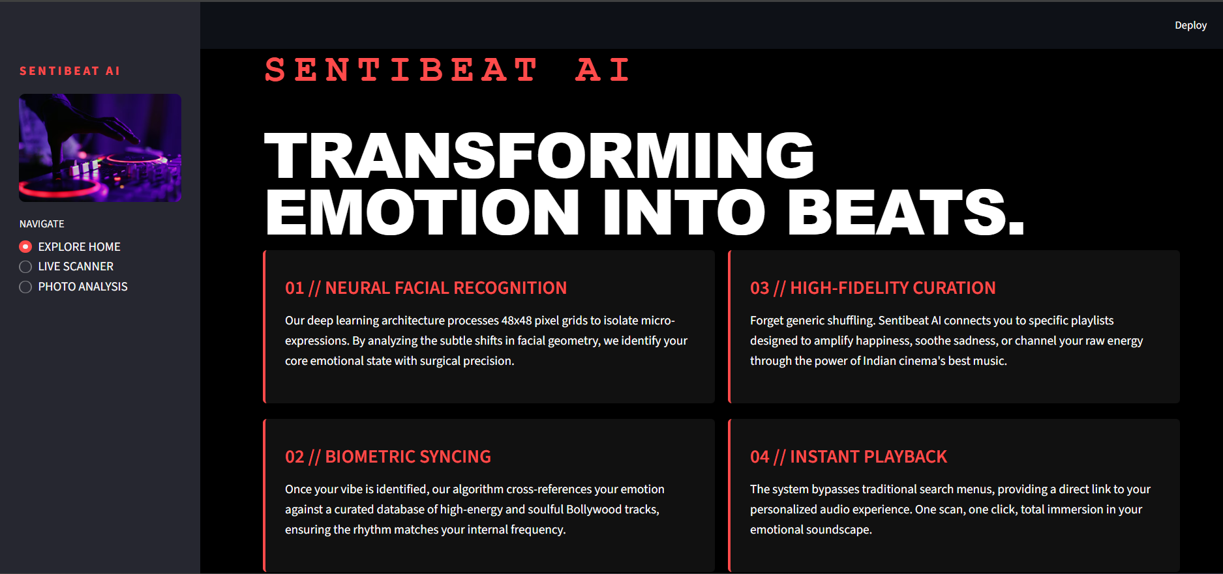
Live scanning :
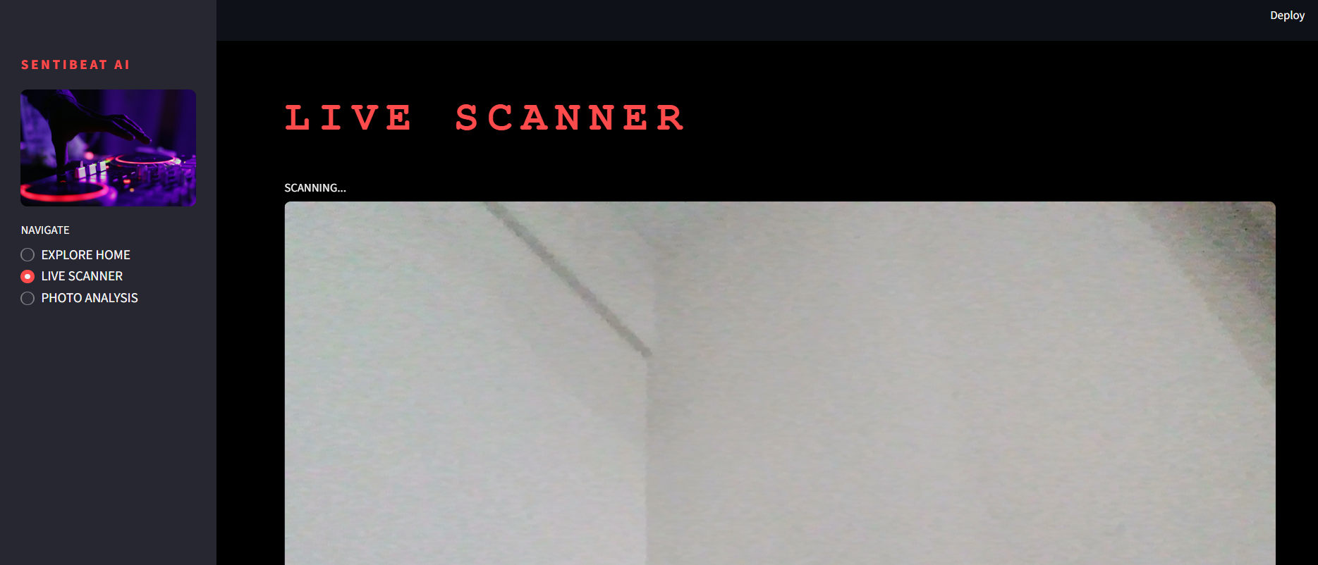

Saved pics sanning:
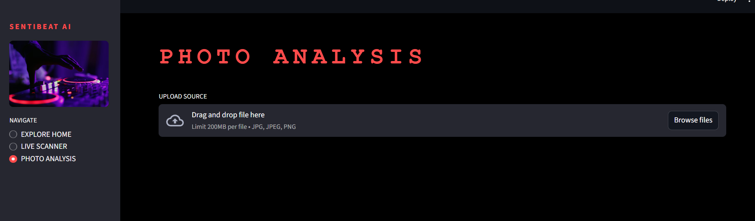
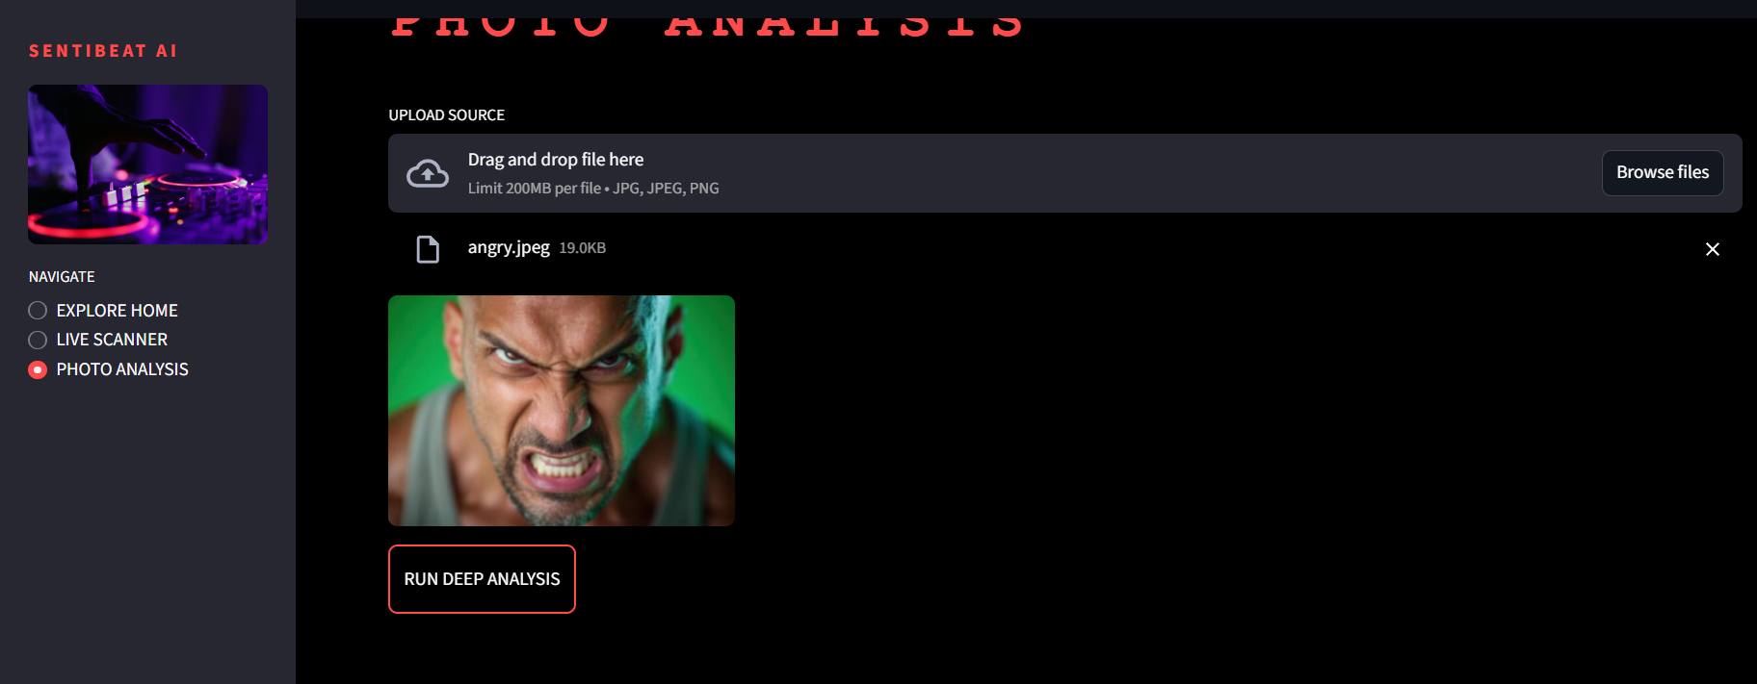
AFTER DEEP ANALYSIS RESULTS:
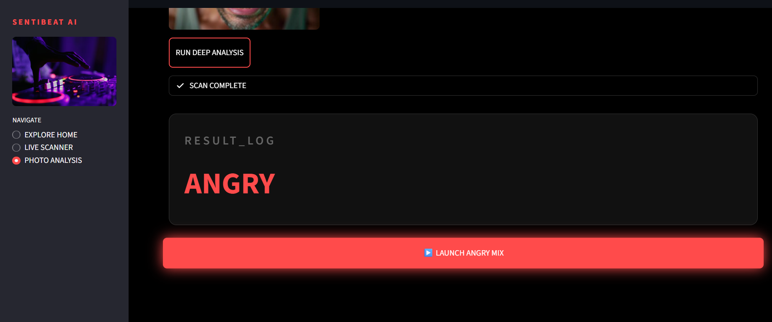

USER INTERFACE FEATURES
Home Page
The home page contains:
- Animated interface
- Project branding
- AI feature descriptions
- Interactive design
- Modern styling using CSS
Live Scanner
The live scanner uses webcam input to analyze emotions in real-time.
Photo Analysis
Users can upload saved pictures for emotion detection.
Result Display
The detected mood is displayed with a styled result box and a playlist launch button.

PLAYLIST MAPPING
Mood | Playlist Type
Happy | Energetic Bollywood Songs
Sad | Emotional and Soft Songs
Angry | Powerful and Intense Music
Neutral | Calm and Relaxing Music
Surprise | Exciting Music
Fear | Dramatic Songs
Disgust | Mood Refreshing Songs

PROJECT SCOPE
The scope of Sentibeat AI includes:
- AI-based entertainment systems.
- Smart recommendation systems.
- Facial emotion recognition applications.
- Mental health and relaxation support.
- Personalized music experiences.
- Real-time computer vision applications.
The project can be used in music applications, wellness platforms, smart assistants, and entertainment systems.

ADVANTAGES OF THE SYSTEM
- Automatic mood detection.
- Real-time emotion analysis.
- Personalized music recommendation.
- User-friendly interface.
- Fast playlist generation.
- AI-based smart interaction.
- Supports both live camera and uploaded images.

LIMITATIONS
- Accuracy depends on lighting conditions.
- Facial expression quality affects prediction.
- Internet connection is required for playlist access.
- Limited mood categories.
- Requires trained deep learning model.

FUTURE DEVELOPMENT
Future improvements for Sentibeat AI may include:
- Spotify API integration.
- Multi-language song recommendations.
- Higher accuracy emotion detection.
- User login and personalized history.
- Real-time facial tracking.
- Voice emotion recognition.
- Mood analytics dashboard.
- AI chatbot integration.
- Mobile application development.
- Support for international music genres.

CONCLUSION
Sentibeat AI is an intelligent Mood-to-Music Recommendation System that combines Artificial Intelligence, Deep Learning, and Computer Vision technologies. The project successfully detects user emotions through facial expressions and recommends suitable music playlists.
The system demonstrates the practical implementation of AI in entertainment and recommendation systems. By integrating Streamlit, TensorFlow, OpenCV, and Python, the project provides an interactive and user-friendly platform for personalized music experiences.
Sentibeat AI proves that Artificial Intelligence can enhance user engagement and create smarter entertainment solutions through emotion-aware systems.

REFERENCES
- Python Documentation – https://www.python.org/
- Streamlit Documentation – https://streamlit.io/
- TensorFlow Documentation – https://www.tensorflow.org/
- OpenCV Documentation – https://opencv.org/
- Keras Documentation – https://keras.io/
- NumPy Documentation – https://numpy.org/

----THANK YOU----

